INDUSTRIAL BATTERY CHARGER BY THYRISTOR FIRING ANGLE CONTROL
ABSTRACT:
The project is designed for charging batteries by DC from AC power supply. DC power for a battery charger is derived from a thyristor controlled rectifier system. AC power is applied to a bridge rectifier comprising of diodes and a triac getting desired control from microcontroller.
The project uses zero crossing point of the waveform which is detected by a comparator whose output is then fed to the microcontroller. The microcontroller provides required delayed triggering control to a triac through opto isolator interface. Finally the power is applied to the load through the triac in series with the bridge rectifier. The rectified and controlled DC output is given to the load i.e., a resistor used in our project in place of a battery. The output DC voltage is measured using a multimeter. This project uses a microcontroller from PIC family which is interfaced through push button switches used for increasing or decreasing the DC voltage for proper charging purposes.
The project can be further enhanced by using direct 230 volt supply instead of 12 volt AC to the bridge rectifier for achieving higher voltage control for charging number of batteries in series.
BLOCK DIAGRAM
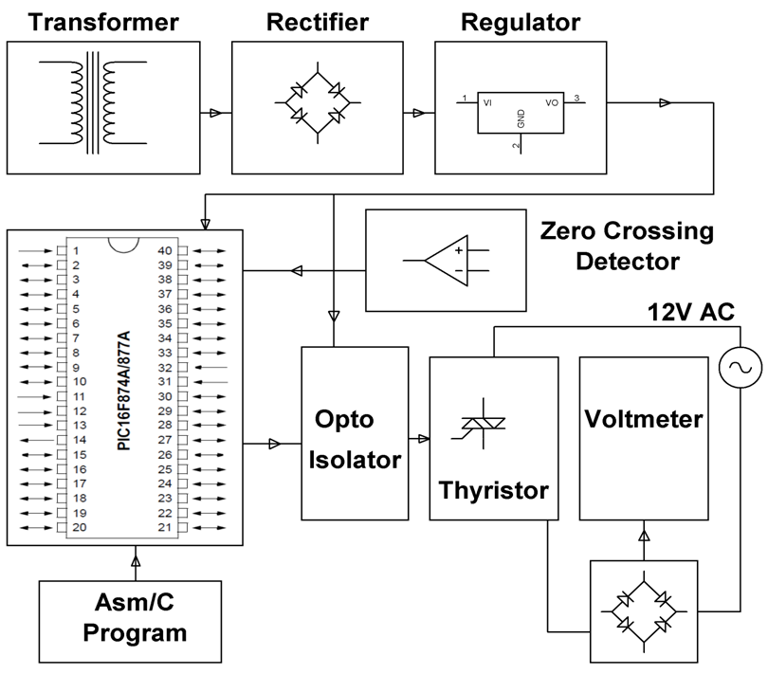
HARDWARE REQUIREMENTS:
PIC series Microcontroller, Op-amp, Opto-Isolator, Triac, Voltage Regulator, Transformer, Diodes, Crystal, LED, Push Button, Resistors, Capacitor, Load.
SOFTWARE REQUIREMENTS:
HI-TECH PICC Tool suite
Language: Embedded C or Assembly

